

**HACETTEPE UNIVERSITY**

**ENGINEERING FACULTY**

**ELECTRICAL AND ELECTRONICS**

**ENGINEERING PROGRAM**

2023-2024

SPRING SEMESTER

ELE708

NUMERICAL METHODS IN ELECTRICAL ENGINEERING

HW4

N23239410 – Ali Bölücü

# Exercises

## 4.2

metin, el yazısı, yazı tipi, diyagram içeren bir resim

Açıklama otomatik olarak oluşturuldu

## 4.3

metin, el yazısı, yazı tipi, sayı, numara içeren bir resim

Açıklama otomatik olarak oluşturuldu

metin, el yazısı, yazı tipi, sayı, numara içeren bir resim

Açıklama otomatik olarak oluşturuldu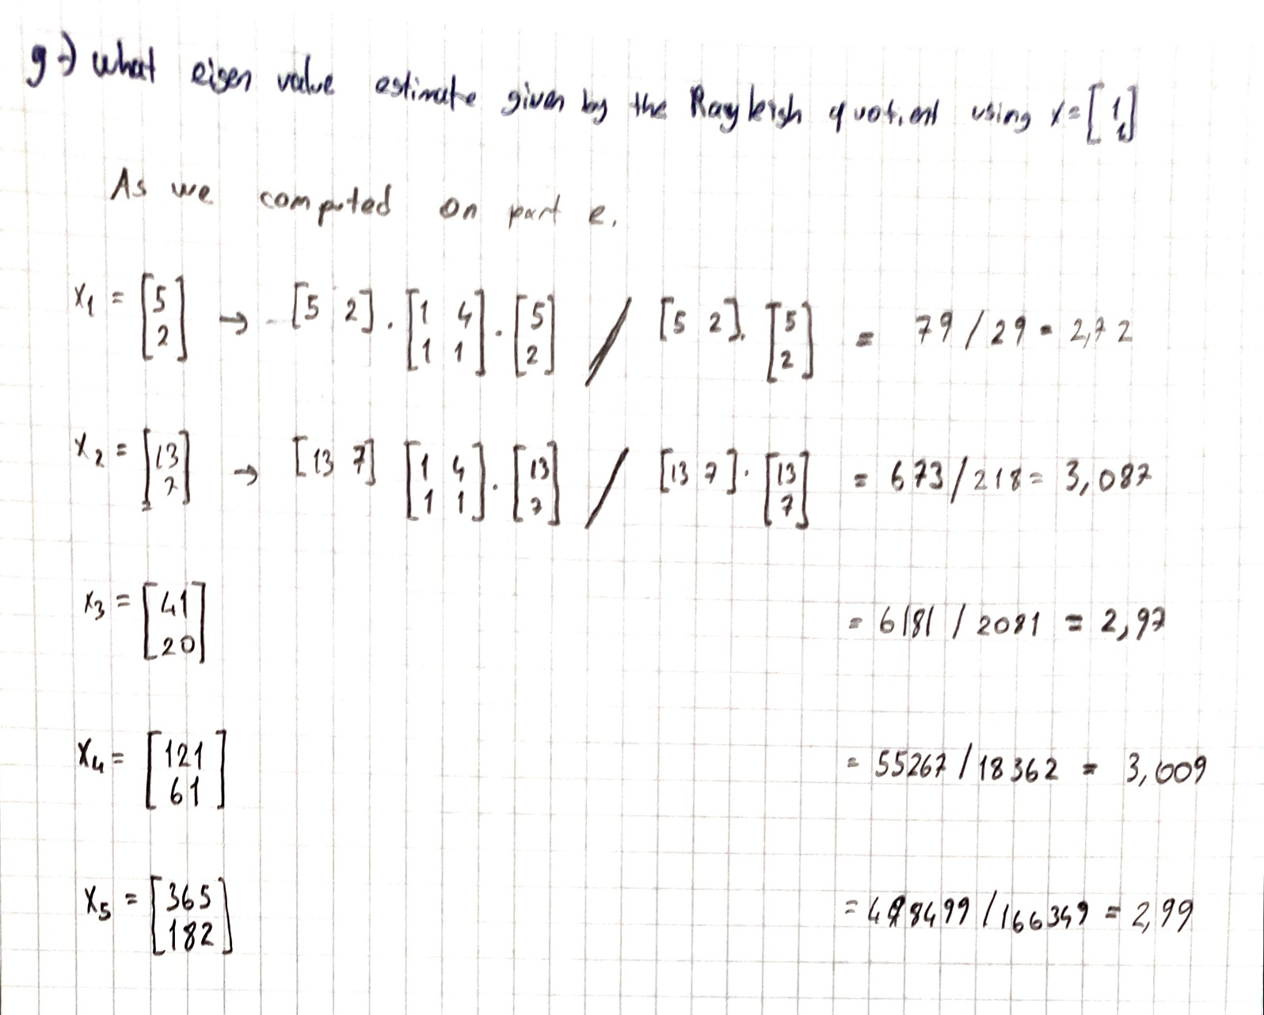

metin, el yazısı, yazı tipi, doküman, belge içeren bir resim

Açıklama otomatik olarak oluşturuldu

# Computer Problems

## 4.5

## (a) Use a library routine to compute the eigenvalues of the matrix

**(b) Compute the eigenvalues of the same matrix again, except with the a33 entry changed to 18.95. What is the relative change in magnitudes of the eigenvalues?**

**(c) Compute the eigenvalues of the same matrix again, except with the a33 entry changed to 19.05. What is the relative change in magnitudes of the eigenvalues?**

**(d) What conclusion can you draw about the conditioning of the eigenvalues of A? Compute an appropriate condition number or condition numbers to explain this behavior.**

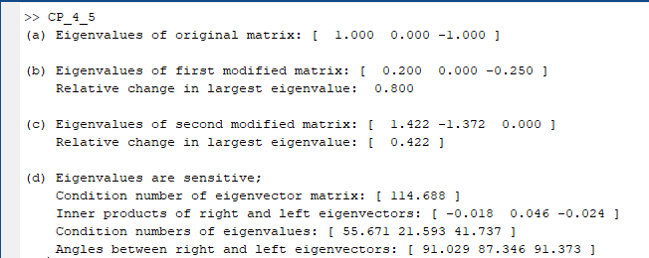

As it can be seen from the image, in ill-conditioned system a little change can cause big changes in the result.

The condition number of matrix A is 4 but this irrelevant for the eigenvalues. Thus, we calculated the condition number of eigenvector. And it tells us that matrix is ill-conditioned.

The inner products and the angle between right and left eigenvectors tell us that these are almost orthogonal to each other. Which makes the eigenvalues easily perpetuated by little changes.

## 4.8

## Compute all the roots of the polynomial

**by forming the companion matrix (see Section 4.2.1) and then calling an eigenvalue routine to compute its eigenvalues. Note that the companion matrix is already in Hessenberg form, which you may be able to take advantage of, depending on the specific software you use. Compare the speed and accuracy of the companion matrix method with those of a library routine designed specifically for computing roots of polynomials (see Table 5.2). You may need to experiment with polynomials of larger degree to see a significant difference.**

The roots of the polynomial and eigenvalues of the matrix give the same answers. We could not see any accuracy differences in this polynomial.

**metin, ekran görüntüsü, yazı tipi, sayı, numara içeren bir resim

Açıklama otomatik olarak oluşturuldu**

## 4.10

## A singular matrix must have a zero eigenvalue, but must a nearly singular matrix have a “small” eigenvalue? Consider a matrix of the form

**1 -1 -1 -1 -1**

**0 1 -1 -1 -1**

**0 0 1 -1 -1**

**0 0 0 1 -1**

**0 0 0 0 1**

**whose eigenvalues are obviously all ones. Use a library routine to compute the singular values of such a matrix for various dimensions. How does the ratio σmax/σmin behave as the order of the matrix grows? What conclusions can you draw?**

As the ratio increases. The matrix gets closer to being singular and it becomes ill-conditioned.

**metin, ekran görüntüsü, yazı tipi, sayı, numara içeren bir resim

Açıklama otomatik olarak oluşturuldu**

**metin, çizgi, ekran görüntüsü, diyagram içeren bir resim

Açıklama otomatik olarak oluşturuldu**

## 4.13

**Consider the generalized eigenvalue problem Kx = λMx derived from the spring-mass system given in Example 4.1 and illustrated in Fig. 4.1. For purposes of this problem, assume the values k1 = k2 = k3 = 1, m1 = 2, m2 = 3, and m3 = 4, in arbitrary units.**

**metin, diyagram, ekran görüntüsü, yazı tipi içeren bir resim

Açıklama otomatik olarak oluşturuldu**

So we can find the frequency by finding the eigenvalues of matrix.

**metin, ekran görüntüsü, yazı tipi, sayı, numara içeren bir resim

Açıklama otomatik olarak oluşturuldu**